1. Name 2 Razor keywords and 2 C# Razor keywords

Razor: model, page

C#: for, if

1. What does the @page directive do?

It identifies the page as a razor page.

1. What is the @model directive do?

It identifies what model should be passed to the view.

1. What folder and file contains the markup that each page shares?

The folder shared and the file _Layout.cshtml

1. What Razor command is a placeholder for other page-specific views to show up?

@RenderBody

1. How does Razor transition into C# code?

Razor transitions to C# code using {}

1. What's the purpose of ViewData?

ViewData is a dictionary for what information should be displayed on a page using a variable.

1. After changing the title element in _Layout.cshtml, run the app and screen print.

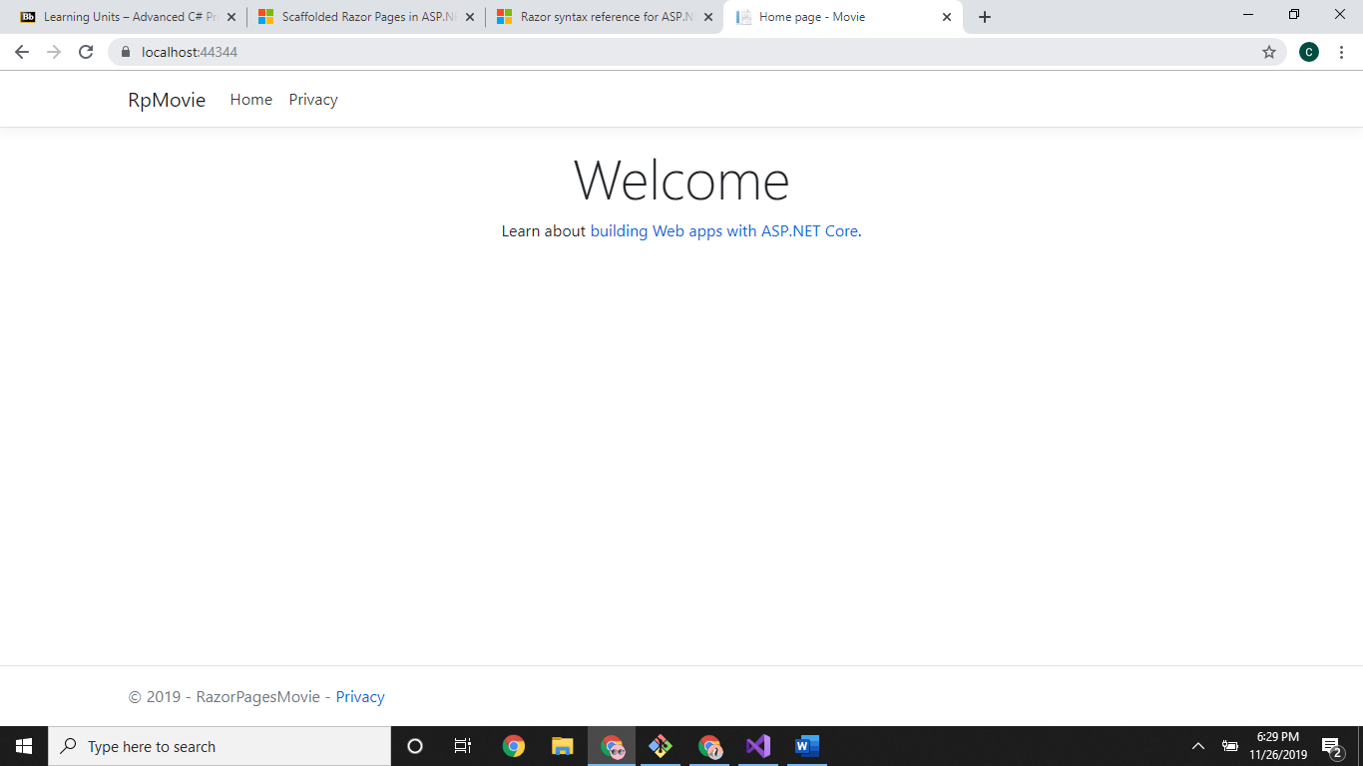

1. When a record is being created, the Create form posts the values to the server. What does ASP.NET then do? What method in the Create.cshtml.cs file is run to do this?

OnPostAsync is run to bind the data to the movie model.

1. What is an antiforgery token?

Antiforgery tokens are divided into two tokens one sent with the client as a cookie while the other is hosted within the form. This guarantees that the request came from the user using the form itself. Otherwise if one of the tokens are missing the server denies the request.

1. List 3 Tag Helpers covered in this tutorial section.

Asp-for, Asp-validation-for, asp-validation-summary.